EXPLOITS UNIVERSITY
FACULTY OF SCIENCE

PROGRAMME OF STUDY : BACHELOR OF INFORMATION AND COMMUNICATION TECHNNOLOGY
FINAL YEAR PROJECT
PROJECT TITLE : WEB-BASED ONLINE PLAYER REGISTRATION SYSTEM: THE CASE OF MALAWI RUGBY UNION (MARU).
YEAR OF STUDY : 4/2
PRESENTED BY : ALLSTER MOMBA
SUPERVISOR : MR N.N. NKHATA
DATE SUBMITTED : 31th JANAUARY 2024

DECLARATION

This research paper is my original work and has not been presented for a degree in any other university.

NAME: Allster Momba

Signature: Date:

CERTIFICATION OF APPROVAL

Supervisor: This proposal has been submitted for the review with my approval as university supervisor.

Signature: Date:

Name: MR N.N. NKHATA

ACKNOWLEDGEMENTS

I dedicate this dissertation to my mother’s Barbra and charlotte for the psycho-social and financial support they rendered me during my school journey. I also thank my supervisor for the role he played when I was gathering the data that I gathered to come up with this complete research. In the same vein I also thank Mr. Benedict Thavela and Mr. Laston Palanjeta for the editorial work during the compilation of the research. I commend all the aforementioned people for the diverse important roles they played on my academic cycle as this has made me reach this higher level of education.

Above all, I thank God for being my light protector and guide throughout the academic journey including the research process.

ABSTRACT

Web-based online player registration system is an online system that will help sports institutions in general and MARU in particular to get the most accurate information about player registration issues. This will enable the sports institutions including MARU to make sound and effective decisions based on the information of the player on this system. MARU staff and coaches will be able to gain immediate access to the information of players and also track their performance. The web-based online player registration system is equipped with features that makes it possible to store and retrieve the information in just a few clicks.

The web-based player online registration system is an application developed in HTML, java script, PHP and MYSQL database back end.to implement this system, the sports institution does not need expensive hardware and software, what is required are internets connection devices such as computers, smartphones, tablets and any other devices . The system works as a centralized database and application. The institutions, coaches and players can access the system from anywhere, anytime based on login credentials through a standard internet access.

Contents
DECLARATION 2
CERTIFICATION OF APPROVAL 3
ACKNOWLEDGEMENTS 4
ABSTRACT 5
LIST OF ABBREVIATIONS 13
LIST OF FIGURES 14
CHAPTER ONE: PROJECT PROPOSAL 15
1.0 Introduction 15
1.1 Background 16
1.1.1 Challenges faced by the current system 16
1.1.2 Proposed solutions 18
1.2 Objectives 19
1.2.1 Minor objectives underline the aforementioned objectives 19
1.3 Problem statement 20
1.4 Significance of the Project 20
1.5 Limitations of the Project 20
CHAPTER TWO: LITERATURE REVIEW 21
2.0 Introduction 22
2.1 Problem definition 22
2.2 Existing Studies 22
2.3 Methodology 27
2.4 Proposed Solution 28
2.5 Relationship between Existing Studies and the Proposed System 34
2.5.1 Technological Relationship 34
2.5.2 Functional Relationship 34
2.5.3 Benefits Relationship 35
2.6 How will it serve the Institution? 35
CHAPTER THREE: DETAILED DESIGN DOCUMENT 35
3.0 Introduction 35
3.1 Goals of the System 36
3.2 Scope of Solution 36
3.3 Constraints 36
3.4 Architectural and Component Level Design 36
3.5 Description of Components 38
3.5.1 User Interface Component 38
3.5.2 Application Logic Component 39
3.5.3 Database Component 40
3.5.4 Database scheme 40
3.6 Data Architecture 42
3.7 User Interface Descriptions 43
3.8 Quality Assurance 46
CHAPTER FOUR: USER MANUAL 47
4.1 Purpose 47
4.2 System Overview 47
4.3 Getting Started 47
4.3.1 Accessing the System 47
4.3.2 User Roles and Permissions 47
4.4 Player Registration 47
4.5 Administrator Dashboard 48
4.6 System Security 48
4.7 Troubleshooting 48
CHAPTER FIVE: SUMMARY 49
REFERENCES 50

LIST OF ABBREVIATIONS
MARU - Malawi Rugby Union
HTML - Hypertext Markup language
PHP - Hypertext Processor
SQL - structured query language.
CSS - Cascading Style Sheets
WBORS - Web-Based onlone registration system
URL- uniform resource locater

LIST OF FIGURES
Fig 1 Context Diagram of the Current System
Fig 2 Chart Diagram comparing the current system with the proposed system
Fig 3. Context Diagram of the Current System Current system
Fig.4 Use case diagram for an online Hotel Booking Management System.
Fig .5 Sequence diagram of the online Student Registration system
Fig .6 Use case diagram for the online Registration system.
Fig .7 Sequence diagram of the online Registration system.
Fig .8 context diagram of the current system.
Fig. 9 Data flow Diagram of the current system
Fig .10 Use case diagram of the proposed system.
Fig.11 the functions which the player can do after login.
Fig. 12 the functions which the Administrator can do after login.
Fig 13 the functions which the coach can do after login
Fig .14 Context Diagram of the Proposed System
Fig .15 Activity diagram
Fig.16 Player Registration's Sequence Diagram
Fig 16 Architectural Diagram
Fig 17 Data flow diagram (Level 0)
Fig 18: Data Flow Diagram (Level 1)
Fig .19 data architecture diagram of the proposed system

CHAPTER ONE: PROJECT PROPOSAL

1.0 Introduction
In the ever-evolving landscape of sports management, the transition from traditional paper-based systems to advanced web-based solutions has become a crucial step for institutions aiming to enhance efficiency, accuracy, and accessibility. The Malawi Rugby Union (MARU), operating under the Malawi Sports Council, currently relies on a paper-based player registration system. However, this method has proven to be time-consuming, error prone, and increasingly impractical as the number of registered players continues to grow.
The challenges inherent in the existing paper-based registration system, such as manual data processing, delays in information retrieval, and the risk of data loss, have necessitated a paradigm shift towards a more technologically advanced approach. In response to these limitations, this project introduces the use of a web-based online player registration system that MARU is going to use in replacement of current system. The aim is to leverage the benefits of modern technology, providing a smooth, efficient, and secure platform that addresses the shortcomings of the current system.
This transition is not merely a technological upgrade; it is a strategic response to the expanding landscape of sports activities and the increasing demand for streamlined administrative processes. By adopting a web-based solution, MARU seeks to revolutionize its player registration procedures, moving from cumbersome manual methods to a more convenient, automated and responsive system. This project delves into the background, challenges, objectives, and significance of the project, outlining a clear path towards the implementation of an advanced player registration system in line with the dynamic needs of the institution and the sporting community it serves.

1.1 Background
The Malawi Rugby Union (MARU) currently operates under a paper-based player registration system, a methodology that, over time, has revealed significant drawbacks. This section delves into the specific challenges faced by the existing system, illustrating the need for a transition to a web-based solution.

1.1.1 Challenges faced by the current system
The paper-based player registration system utilized by MARU, while once a conventional approach, and has become increasingly cumbersome as the demands on sports administration grow. The paper based system faces numerous challenges and this project discusses key challengers in details.
Data Entry Errors is one of the key challengers. High Error Rates in data entry, the manual nature of data entry onto paper forms, introduces a notable risk of errors in player information. An internal audit revealed an average error rate of approximately 10% in player profiles. Common errors include misspelled names, inaccuracies in birthdates and other data entry-related mistakes. This high error rate compromises the accuracy and reliability of the player database, necessitating corrective actions that consume additional time and resources.
Next, data damage and Retrieval Delays as well as the reliance on physical paperwork expose the system to the risk of data loss due to misplacement or other unforeseen circumstances. Manual documents can easily be damaged, lost, misplaced or stolen. For example arsons, rains, winds and other calamities could mean the loss of essential information. If one in office does not have any back-up copies, once the files are gone, there is no way of getting the information back. Additionally, retrieving specific player information becomes a time-consuming process whereby hampering the efficiency of administrative tasks. On average, the time from a player submitting a registration form to their information being fully processed and accessed can extend from 5 to 7 days. This delay hinders the timely inclusion of players in team activities and competitions, adversely affecting the overall agility of the sports administration.
Apart from data damage and retrieval delays, Scalability is also a challenge. Scalability refers to the ability of great increase in capacity, with relative ease. As sports institution grows or undergoes seasonal fluctuations, the existing system may struggle to scale efficiently. This can result in bottlenecks, delayed processing and an overall decline in system performance.
In addition to that Manual Paperwork and Administrative Burden create a vivid challenge to the current system. Traditional methods involve extensive paperwork, manual data entry and administrative overhead. This not only consumes valuable time but also increases the likelihood of errors and data inconsistencies.
Furthermore, paper based player registration system is also exposed to Limited Accessibility and Collaboration. The paper based nature of the system restricts access of player information to specific physical locations like MARU offices. For example, Survey results indicate that 85% of coaches experience of challenges accessing player information promptly. This limitation inhibits real-time collaboration among stakeholders, hindering the ability of coaches, administrators, and players from making informed decisions and effective plans.

Fig 1 Context Diagram of the Current System

Registering

MARU registrar Office
Registration feedback
Form submission
MARU Office
MARU Region office

Submits the form

Registration form
Player

The following context diagram visually represents the current paper-based player registration system illustrating the flow of information within the current system with the emphases of the manual nature of data collection, storage, and retrieval.

Fig 2 Chart Diagram comparing the current system with the proposed system

In summary, the combination of time delays, high error rates, limited accessibility, and an increased risk of data loss underscores the critical need for a transition to a more efficient and technologically advanced player registration system at MARU.

1.1.2 Proposed solutions
The project will provide the following proposed solution to the current system. It will also provide the best solution a sporting institution should choose for the operation of this system.
The initial system is mobile application. This is a software program that runs on a mobile device such as a smartphone or a tablet. A mobile application usually performs a single function and can be easily installed and uninstalled from the device.
Apart from that, a desktop application is another proposed solution. This is a software program that runs on a traditional computer such as a laptop or a desktop. A desktop application can perform multiple functions simultaneously and often requires more time and resources to install and uninstall.
Moreover, a web based management system, a software program that operates on the internet and allows the management of various aspects of a business or an organization, is another solution. A web based management system can be accessed from any device that has a web browser and an internet connection.
Saliently, the chosen solution is the web-based management system for several reasons some of them include, higher accessibility and compatibility, Lower development costs and time, Easier maintenance and updates, Better integration and interoperability, higher security and reliability.

1.2 Objectives
The objectives of introducing a web-based online player registration system for MARU are structured to address specific challenges and bring about comprehensive improvements.

To reduce inefficiencies the current system undergoes

To highlight the occurrence, accessibility and haste of the modern web based system

To explain the functionality of the web based system and its resilience to the present adverse weather conditions in terms of data storage

1.2.1 Minor objectives underline the aforementioned objectives
- Automation and Efficiency
- Enhanced Security
- Improved Communication
- Scalability and Adaptability
- Accessibility and Inclusivity

1.3 Problem statement
For a period of time, paper-based traditional has been the mode of collection and management of data almost in all sporting institutions in general and MARU in particular. The literature has it that the traditional way of data management was the reliable system before technological advancement; however, it set out some existing problems this system goes through. For example the paper based registration system is prone to errors and information can be easily altered or misrepresented due to poor storage and management systems resulting in delays in processing player information, intensive manual labour and lack of storage space.in an attempt to resolve these problems, the research studies the best way of data management by focusing on a web based online player registration system. Which will benefit, especially MARU by increasing its efficiency, effectiveness and competitiveness in the sport sector. The research opines that the web-based registration system can solve these challenges by automating the data collection and management process, reducing errors and costs, improving data quality and security and enabling easy access and analysis of player data.
While existing studies provide valuable insights, there is a noticeable gap specific to the context of player registration within a sports union like MARU. The proposed system aims to address this gap by tailoring the approach to the unique requirements and challenges faced by MARU in managing player registration processes.

1.4 Significance of the Project
The researcher justifies this project because he understands the state of knowledge as he is well versed with the traditional system that MARU is currently using pausing it to problems already mentioned in other sections in the project. The research therefore seeks to find out how the web based online registration system can be used in player registration to improve efficiency in all sporting institutions

1.5 Limitations of the Project
It is crucial to acknowledge and address potential limitations during the development of the web-based online player registration system for MARU Each limitation is accompanied by strategies to mitigate its impact:
- Limited Resources: Despite limited resources, the project aims to maximize efficiency through careful planning and prioritization. The development process will focus on essential features first and resource allocation will be optimized to ensure critical components are addressed within the available resources. Additionally, seeking partnerships or collaborations with external entities may provide supplementary resources and expertise.

- Limited User Feedback: To overcome limited user feedback, an iterative development approach will be adopted. Regular feedback sessions will be scheduled with key stakeholders, including coaches, administrators, and players, to gather insights and incorporate suggestions into subsequent development phases. The implementation of a user-friendly interface and ongoing communication channels will encourage continuous feedback.

- Limited Timeline: The project's timeline is constrained to three months. To ensure timely completion, a well-defined project plan with clear milestones will be established. Task prioritization and parallel development of certain components will be considered to optimize the timeline. Additionally, regular progress assessments and adjustments to the plan will be made to accommodate unforeseen challenges.
By proactively addressing these limitations, the project aims to minimize their impact and ensure a successful and timely implementation of the web-based player registration system. Continuous monitoring and adaptability in response to changing circumstances will be key to overcoming challenges and delivering a quality product within the given constraints.
In summary, this chapter has introduced the web based online player registration system that can replace the current paper based registration system.it has also shown the challenges the current system faces in reference to how this system works at MARU. Additionally, it has also emphasized on the use of the web based online registration system by vindicating possible solutions the system has to the paper based registration system. Therefore the project discusses further how the system can work in subsequent chapters.

CHAPTER TWO: LITERATURE REVIEW

2.0 Introduction
Web-Based Online Registration systems have become integral in enhancing administrative processes across various sectors, leveraging benefits such as convenience, efficiency and accuracy. This section examines the existing literature that focuses on significance of Web-Based Online Registration systems.

2.1 Problem definition
Web-Based Online Registration systems have proven to be vital in streamlining administrative processes across various sectors. However, within the specific context of player registration MARU faces several challenges, prompting the need for a dedicated Web-Based Online Player Registration system to solve them. The identified problem stems from the inefficiencies and challenges associated with the current Paper-Based Registration system at MARU. Issues such as time delays, high error rates, limited accessibility and an increased risk of data loss demand a modernized approach.
Fig 3. Context Diagram of the Current System Current system

Player

Registering

MARU registrar Office
Registration feedback
Form submission
MARU Office
MARU Region office

Submits the form

Registration form

2.2 Existing Studies
The proposed Web-Based Online Player Registration system draws inspiration from existing studies and models related to online registration systems. This section reviews notable studies and their methodologies while emphasizing their relevance to the proposed system.
According to the case study Ahmad Saleh Alhumaidi (2021) Studied, designed and implemented an online Hotel Booking Management System. The system, which was developed using PHP, Apache, HTML5 and JavaScript demonstrated benefits such as scalability, flexibility, and interoperability. Performance testing and user feedback confirmed positive results in terms of speed, accuracy, efficiency and effectiveness.
Fig.4 Use case diagram for an online Hotel Booking Management System.
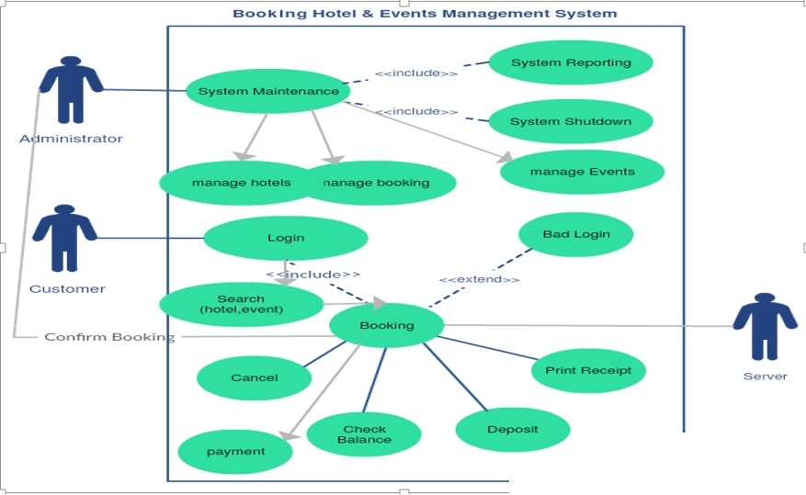

Fig .5 Sequence diagram of the online Student Registration system.

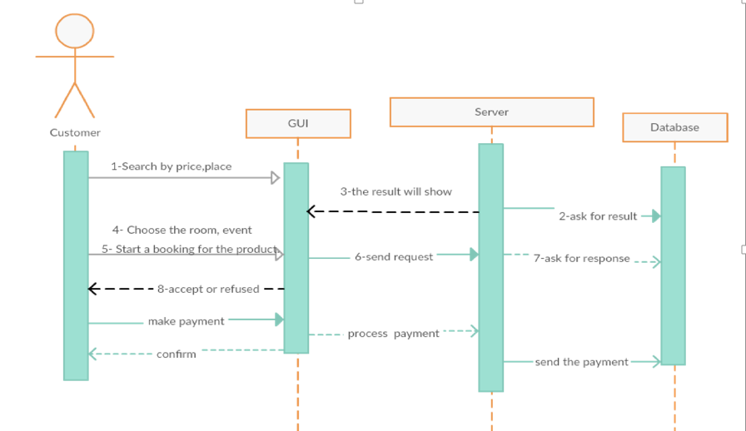

Richard K. Bemile, Juanita Gborgla, Paul Owusu Mensah, Victoria Boateng, Hayford Ofori Ansa and Eric Gyebi Twum (2015) designed and implemented an Online Registration System for Methodist University College, Ghana. The system, developed using PHP, MySQL, HTML, CSS, and JavaScript, showcased advantages such as manageability, consistency, and ease of use, functionality, reliability, security, speed, accuracy, efficiency and effectiveness.

Fig .6 Use case diagram for the online Registration system.

Report
Administrator

Student

File Update

System Login

Manage
Accounts

Student
Registration

Fig .7 Sequence diagram of the online Registration system.

These studies collectively highlight the positive outcomes achieved through the transition from traditional paper-based systems to web-based platforms. Key themes include increased efficiency, reduced processing time, enhanced accessibility and improved collaboration themes that resonate with the proposed implementation of an online web-based player registration system for MARU. The examination of existing studies on web-based registration systems, particularly those by Ahmad Saleh Alhumaidi (2021) and Richard K. Bemile, Juanita Gborgla, Paul Owusu Mensah, Victoria Boateng, Hayford Ofori Ansa and Eric Gyebi Twum (2015), provides a robust foundation for the proposed Web-Based Online Player Registration system for MARU. The identified benefits of scalability, flexibility, and efficiency resonate with MARU's objectives. Leveraging these insights, the MARU system aims to deliver a tailored, user-friendly platform that not only meets current needs but also positions the union for future growth and adaptability. This exploration validates the chosen technological framework and sets the stage for a sophisticated and reliable online player registration system.

2.3 Methodology
The project has used various data collection instruments, including interviews and observations, to gather information from players, coaches and MARU staff. Examination of MARU registration records and the application of modeling tools such as Data Flow Diagrams (DFD), Use Case Diagrams and Sequence diagrams were employed to represent both the existing and proposed systems. The process of registration involves step-by-step interdependent actions that work together to produce outcomes.
Fig .8 context diagram of the current system.

Enquiry/
Complaint
Details
Registration
Details
Player
Details
Player details
Registration details
Details
Player
Complaints
Registration
System
Player

1. Introduction: The Malawi Rugby Union (MARU) currently employs a paper-based player registration system, facing challenges such as data entry errors, delays, limited accessibility, and the risk of data loss. The proposal suggests transitioning to a web-based system to address these issues, providing a more efficient, accurate, and secure platform.
2. Background: The paper-based system poses challenges like data entry errors, delays, and limited accessibility. Visual representations illustrate the manual flow of information in the current system.
3. Problems of the Current System: The current system suffers from time delays, high error rates, limited accessibility, and an increased risk of data loss. Proposed solutions include a mobile application, desktop application, and a web-based management system, with the latter chosen for its higher accessibility, lower development costs, easier maintenance, better integration, and security.
4. Objectives: The specific objectives of implementing a web-based system include efficient online registration, enhanced data accuracy, improved accessibility, comprehensive administrator tools, user authentication, system deployment and training, integration of reporting tools, and enhanced user experience.
5. Significance of the System Project: The web-based system addresses time delays, high error rates, limited accessibility, and the risk of data loss in the current system. It aims to automate processes, reduce errors, enhance accessibility, and eliminate the reliance on physical paperwork.
6. Limitations of the Project: Acknowledging limitations such as limited resources, user feedback, and timeline, the project plans to maximize efficiency, adopt an iterative development approach, and establish a well-defined project plan to address these challenges.
7. Summary: The implementation of the web-based online player registration system at MARU represents a transformative shift, addressing key challenges and bringing efficiency, accuracy, and accessibility to the player registration process.
8. Budget: The budget for the system development proposal includes costs for a Yanga bundle (70GB) and transportation, totaling MK 105,000.
Abbreviations:
- MARU: Malawi Rugby Union
- WBOPRS: Web based online player registration system

You
1. Introduction: The Malawi Rugby Union (MARU) currently employs a paper-based player registration system, facing challenges such as data entry errors, delays, limited accessibility, and the risk of data loss. The proposal suggests transitioning to a web-based system to address these issues, providing a more efficient, accurate, and secure platform.
2. Background: The paper-based system poses challenges like data entry errors, delays, and limited accessibility. Visual representations illustrate the manual flow of information in the current system.
3. Problems of the Current System: The current system suffers from time delays, high error rates, limited accessibility, and an increased risk of data loss. Proposed solutions include a mobile application, desktop application, and a web-based management system, with the latter chosen for its higher accessibility, lower development costs, easier maintenance, better integration, and security.
4. Objectives: The specific objectives of implementing a web-based system include efficient online registration, enhanced data accuracy, improved accessibility, comprehensive administrator tools, user authentication, system deployment and training, integration of reporting tools, and enhanced user experience.
5. Significance of the System Project: The web-based system addresses time delays, high error rates, limited accessibility, and the risk of data loss in the current system. It aims to automate processes, reduce errors, enhance accessibility, and eliminate the reliance on physical paperwork.
6. Limitations of the Project: Acknowledging limitations such as limited resources, user feedback, and timeline, the project plans to maximize efficiency, adopt an iterative development approach, and establish a well-defined project plan to address these challenges.
7. Summary: The implementation of the web-based online player registration system at MARU represents a transformative shift, addressing key challenges and bringing efficiency, accuracy, and accessibility to the player registration process.
8. Budget: The budget for the system development proposal includes costs for a Yanga bundle (70GB) and transportation, totaling MK 105,000.
Abbreviations:
- MARU: Malawi Rugby Union
- WBOPRS: Web based online player registration system

You

MARU Registration Office
Handled complaints

Fig. 9 Data flow Diagram of the current system.

Yes
Start

Registration form

Submits form

MARU region office

MARU registrar Office

Terminate

New
Player?
Complete Registration

2.4 Proposed Solution
To obtain information about the player registration system, it was necessary to interview players the responsible staff at MARU Offices and coaches of different teams. Getting to know how the rugby union conducts its registration helped flag any apparently unusual aspects. Understanding the concerns of players helped to incorporate them in the development of the proposed online player registration system. With the collected data, a use case diagram was developed to incorporate the actors of the system. Player’s coaches and administrator play a critical role as actors. It is likely that other actors may be added in subsequent iterations. Fig. 3 shows the use case diagram and the context diagram of the proposed system.

Fig .10 Use case diagram of the proposed system.

Update files
Reports
System login
Manage
Accounts
Player
Registration

Administrator

Player

Fig.11 the functions which the player can do after login.
Login
Logout
View personal information
View gallery
Edit profile
Include
Include

Fig. 12 the functions which the Administrator can do after login.
Login
Logout
View personal information
Player coach and team infor
Edit profile
Include
Include

Modifying details

Register player, coach and Admin

Fig 13 the functions which the coach can do after login
Login
Logout
View personal information
View report
Edit profile
Include
Include

View team information

Fig .14 Context Diagram of the Proposed System

Registration
Details
Player
Registration
Report
Registration
Receipt
Upload/Update
Details
Registration Report
Registrar Office
Administrator

Web based Online Player Registration System

The player registration subsystem is the core of the web-based system, streamlining real-time registration processes and overcoming challenges from the old paper-based system.

Fig .15 Activity diagram
Describes dynamic aspects of the system .It is basically a flow chart to present the flow o from one activity to another activity. The activity can be described as an operation of the system so, the control flow is drawn from one activity to another.
Yes
No
Yes
Yes

Do functions
Do functions

Save changes
Save changes

No
No
Check login information
Define the kind of user
Player or coaches
Admin
User login

Fig.16 Player Registration's Sequence Diagram

Database
Update
Login
Registration
Page
Check Duplication
Registration System
Player

Confirm
Update
Registration report

2.5 Relationship between Existing Studies and the Proposed System
A hotel management system, a student registration system, and the proposed player registration system are all software solutions that assist organizations in managing various aspects of their operations, including data collection, processing, storage, and communication. These systems share commonalities in methodologies, technologies, and positive outcomes that can be applied to enhance the proposed system. Here are the key relationships:

2.5.1 Technological Relationship
Both existing studies utilized a similar technology stack, including PHP, HTML, CSS, and JavaScript. The proposed system can benefit from adopting a technology stack that has proven to be effective in developing scalable, flexible, and user-friendly web applications.

2.5.2 Functional Relationship
Positive outcomes from the existing studies, such as functionality, ease of use, and effectiveness, guide the development of the player registration system. Emphasis is placed on providing a robust set of features and a user-friendly interface to meet the needs of both players and administrators.

2.5.3 Benefits Relationship
The identified benefits in both studies, such as scalability, flexibility, manageability, consistency, and security, are also considered in the design and implementation of the proposed player registration system. The aim is to achieve these benefits and create a system that is robust, adaptable, and secure.
By recognizing and leveraging these relationships, inspiration and guidance have been drawn from the successes and methodologies of these existing studies to enhance the development of the Web-Based Online Player Registration system. This approach will contribute to the creation of a system that not only meets industry standards but also incorporates proven practices for optimal performance and user satisfaction.

2.6 How will it serve the Institution?
The proposed Web-Based Online Player Registration system aims to serve MARU by introducing efficiency, accuracy and enhanced accessibility in player registration processes. It will streamline operations, reduce error rates, and provide a secure and efficient data management platform.
In conclusion, the literature review highlights the significance of Web-Based Online Registration systems, reviews relevant studies and models, proposes a methodology for the project, identifies the problem, outlines the gap in existing literature, and discusses how the proposed system will serve MARU. The following chapters will delve into the detailed design, development, and implementation of the Web-Based Online Player Registration system.

CHAPTER THREE: DETAILED DESIGN DOCUMENT

3.0 Introduction
The Online Player Registration System is an advanced software solution designed to revolutionize and simplify the player registration process within sports clubs or organizations. This system leverages cutting-edge technology to create a seamless experience for both administrators and players, optimizing the entire player registration workflow.

3.1 Goals of the System
- Streamlining Registration: Simplify the often complex and time-consuming player registration procedures
- Enhanced Efficiency: Improve the efficiency of data processing and reduce manual errors associated with traditional registration methods
- Security and Compliance: Provide a secure platform compliant with data protection regulations for storing and managing sensitive player information

3.2 Scope of Solution
The Web-based Online Player Registration System will cover a comprehensive range of features, including:
- Player Profile Management: Creation, modification and retrieval of player profiles
- Document Submission and Verification: A secure mechanism for players to submit necessary documents with an integrated verification process
- Communication Tools: messaging system for effective communication between administrators and players
- Reporting and Analytics: Generate reports and analytics for administrators to gain insights into player registration trends and statistics

3.3 Constraints
The system will operate within the following constraints:
- Browser Compatibility: The system will be compatible with modern web browsers to ensure a consistent user experience.
- Internet access: problems from internet service provider which may affect the online services

3.4 Architectural and Component Level Design
Below is a diagram that describes the high level of the proposed system under development.
Fig 16 Architectural Diagram
Registration details
Registration details
PLAYER
REGISTARTION
SYSTEM (PRS)

Registration Report

PLAYER
Registration
Report
Upload/Update
Details
Registration Report
COACH
ADMINISTRATOR

Fig 17 Data flow diagram (Level 0)

Admin
User
Respond
Request
Player registration system (PRS)

Request
Respond

Fig 18: Data Flow Diagram (Level 1)
Register
Player
Player registration system (PRS)
Profile
Login
Administrator
Login
Updates
View team
Gallery
Log out
Modifying details
Login
Register
Coach
Log out
View team
Profile
Log out
Add or remove

3.5 Description of Components

3.5.1 User Interface Component
This component is responsible for rendering the user interface and includes the following elements:
- Player Registration Forms: This interface allows players to input and submit their registration details securely. It is designed to be user-friendly, facilitating a smooth registration process.
- Admin Dashboards: An intuitive dashboard is developed for administrators. It provides an overview of registered players, pending verifications and communication tools. The dashboard enhances the administrator's ability to manage and monitor the player registration process effectively.
- Document Submission Interfaces: This part of the user interface handles the submission of necessary documents by players. It ensures a secure mechanism for document submission and integrates a verification process.
- Technology Stack: The User Interface Components are developed using a combination of HTML, CSS, MySQL, PHP and JavaScript to create responsive and interactive interfaces.
- PHP stands for Hypertext Preprocessor. It is an open-source scripting language. It is widely used across the globe for web development. This language is embedded in HTML and used for handling the dynamic content of the website as well as the databases. All the elements are integrated into web pages using PHP and with that, it has also been used to make and manage the database of the player. PHP has provided efficiency to the normal code and has made it secure and simple.
- MySQL is basically a database management system. This tool is also open source and is available for everyone to use. It helps us to store data in the form of tables. The main advantage of MySQL is that it is used to handle huge bulk of data. This research has used this tool to store the details of the players such as their names, emails and passwords etc. so that the players can register and access their accounts any time.
- HTML it is a language that is used for Web Development. It is used to make the basic layout of a website or a Webpage. The research define the basic structure of Webpage using this language. This paper has used HTML to make various pages such as login page, player Registration, coach Registration etc.
- CSS this is used to beautify our webpage. While HTML provides the basic layout, CSS describes how these HTML elements should be displayed.
- Java Script is also a programming language of the web. It is integrated with HTML. It is used to make responsive and fast websites. The dynamics of the website is given by JavaScript while HTML and CSS are used for static purpose only.

3.5.2 Application Logic Component
This component is responsible for handling the core functionality of the system and includes the following elements:
- Registration Workflow Management: Manages the entire player registration workflow, ensuring a smooth and automated process
- Input Validation and Processing: Validates and processes user input to minimize errors associated with traditional registration methods
- Business Logic Implementation: Implements business logic to ensure that the system meets its goals and objectives effectively

3.5.3 Database Component
This component is responsible for storing and retrieving data securely and includes the following elements:
- Player Profiles: Stores comprehensive player information
- Document Records: Manages documents submitted by players.
- Communication Logs: Records all communication between administrators and players, enhancing accountability

3.5.4 Database scheme
- Entity details

CREATE TABLE Users (

User ID INT PRIMARY KEY AUTO_INCREMENT,

First Name VARCHAR (50) NOT NULL,

Last Name VARCHAR (50) NOT NULL,

Email VARCHAR (100) UNIQUE NOT NULL,

Password VARCHAR (255) NOT NULL,

User Type ENUM ('Player', 'Coach', 'Admin') NOT NULL

);

CREATE TABLE Player Profile (

Player ID INT PRIMARY KEY,

Position VARCHAR (50),

CONSTRAINT fk_player_profile FOREIGN KEY (PlayerID) REFERENCES Users(UserID)

);

CREATE TABLE CoachProfile (

CoachID INT PRIMARY KEY,

TeamName VARCHAR (50),

CONSTRAINT fk_coach_profile FOREIGN KEY (CoachID) REFERENCES Users (UserID)

);

CREATE TABLE Teams (

TeamID INT PRIMARY KEY AUTO_INCREMENT,

TeamName VARCHAR(50) UNIQUE NOT NULL

);

CREATE TABLE Reports (

ReportID INT PRIMARY KEY AUTO_INCREMENT,

CoachID INT,

ReportText TEXT,

CONSTRAINT fk_reports_coach FOREIGN KEY (CoachID) REFERENCES Users(UserID)

);

CREATE TABLE Updates (

UpdateID INT PRIMARY KEY AUTO_INCREMENT,

UserID INT,

UpdateText TEXT,

CONSTRAINT fk_updates_user FOREIGN KEY (UserID) REFERENCES Users(UserID));

CREATE TABLE Settings (

AdminID INT PRIMARY KEY,

SettingName VARCHAR(50),

SettingValue VARCHAR(255),

CONSTRAINT fk_settings_admin FOREIGN KEY (AdminID) REFERENCES Users(UserID));

3.6 Data Architecture
Fig .19 data architecture diagram of the proposed system
Document Records
Document ID (PK)
Player ID (FK)
Document Type
Document Content
Verification Status

Player Profiles
Player ID (PK)
First Name
Last Name
Date Of Birth
Contact Details

Communication Logs
Log ID (PK)
Sender ID (FK)
Receiver ID (FK)
Message Type
Timestamp

SYSTEM
Player Registration system

3.7 User Interface Descriptions
3.7.1 Welcome page

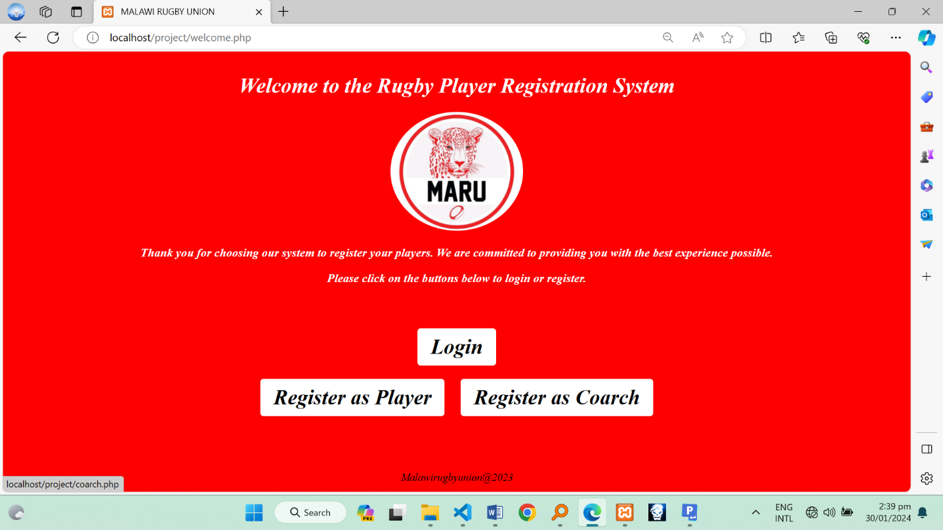
3.7.2 Login page

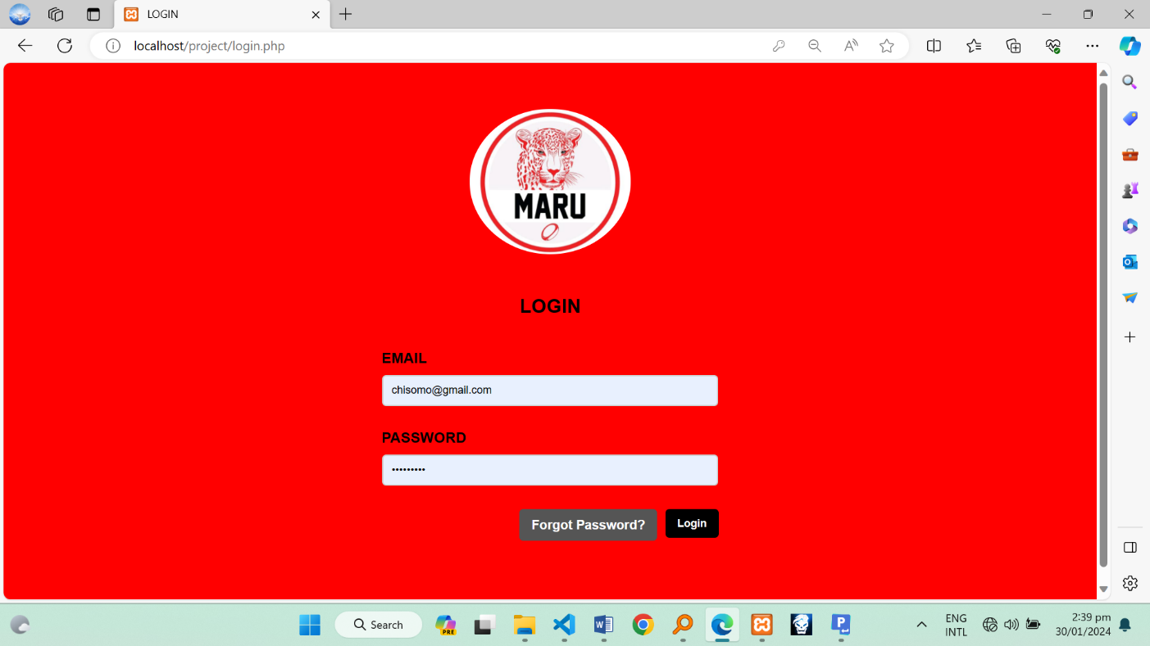
3.7.3 Player Registration Form

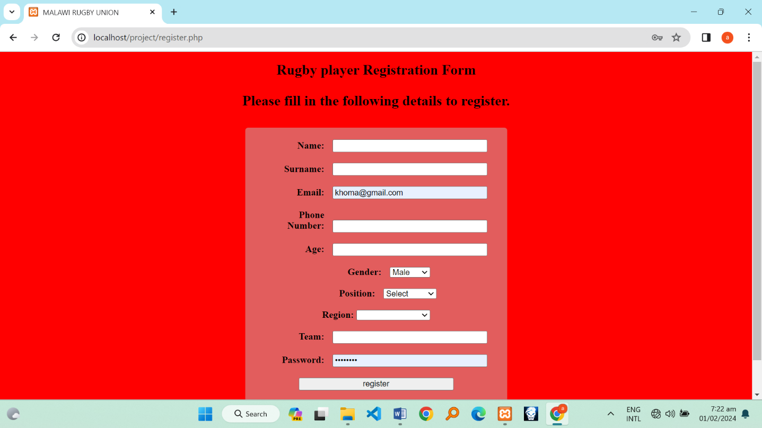
3.7.4 Coach registration form

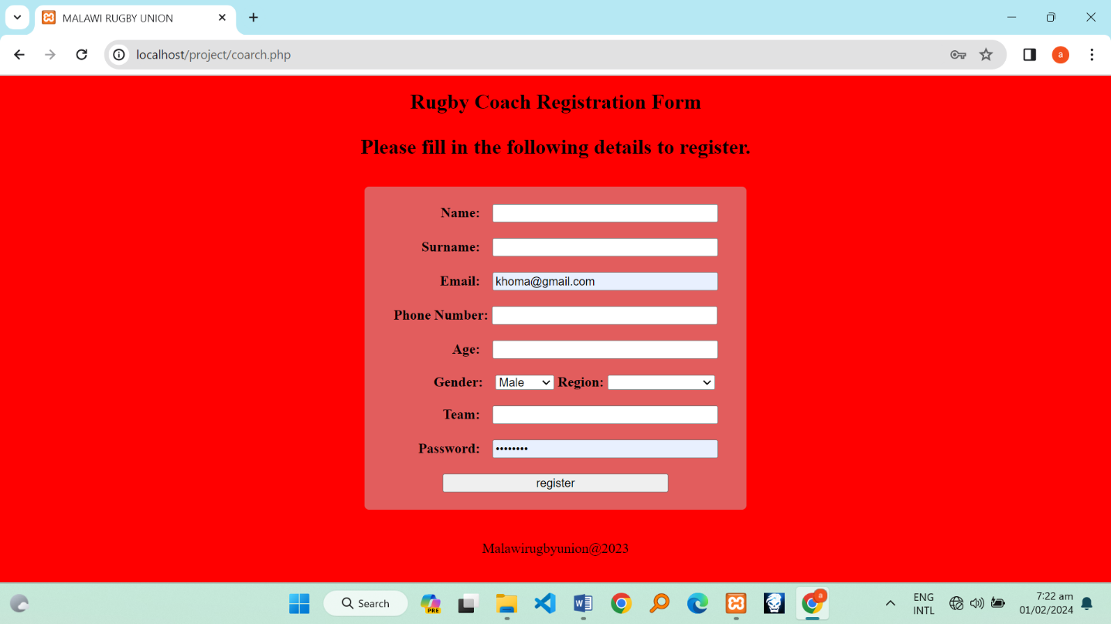

3.7.5 Player profile

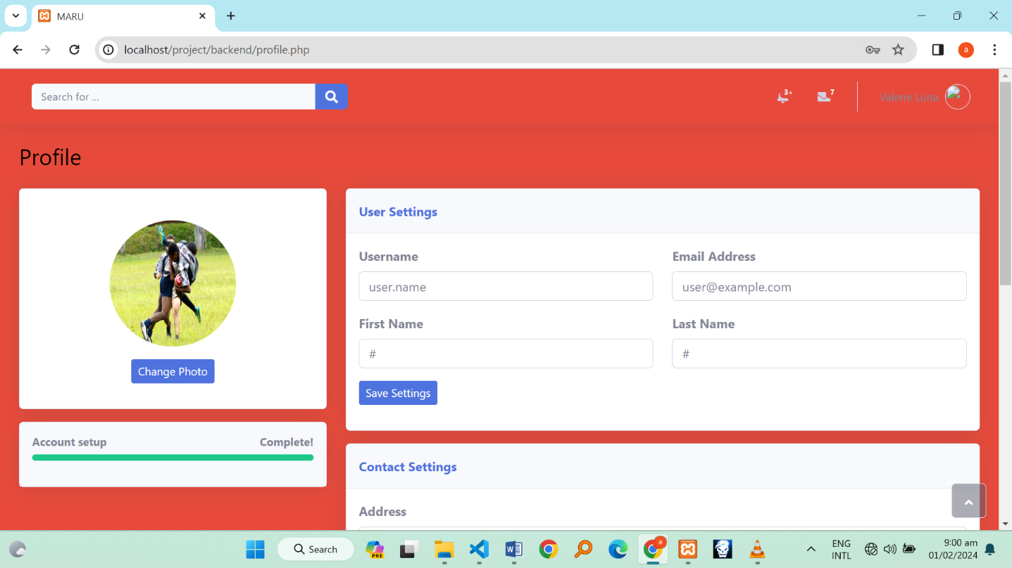
3.7.6 Admin Dashboard

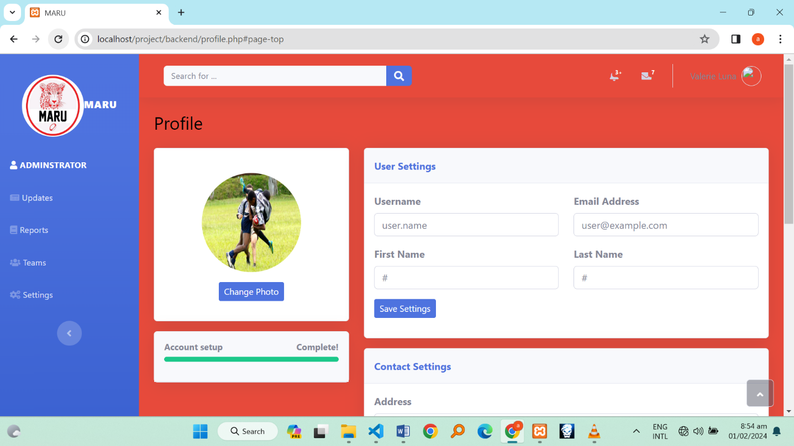

3.8 Quality Assurance
A rigorous testing plan will be executed, including:
- Unit Testing: Ensuring individual components function as intended
- Integration Testing: Verifying the seamless integration of different system components
- User Acceptance Testing: Involving end-users to ensure the system meets their needs
In conclusion the web-based Online Player Registration System detailed design encompasses a robust architectural framework, comprehensive component descriptions, detailed data architecture, and user interface specifics. The focus on quality assurance ensures a secure, efficient, and user-friendly system for player registration within sports clubs.

CHAPTER FOUR: USER MANUAL

4.1 Purpose
Welcome to the Online Player Registration System. This user manual is designed to guide player’s coaches and administrators through the system's features and functionalities. Whether you're a player looking to register or an administrator managing the registration process, this manual will provide step-by-step instructions.

4.2 System Overview
The Online Player Registration System is a web-based platform developed to streamline and simplify the player registration process. It includes features such as player profile management, document submission, verification and communication tools. Administrators can efficiently monitor and manage player registrations, ensuring a secure and efficient workflow.

4.3 Getting Started

4.3.1 Accessing the System
Players and administrators can access the system by navigating to the provided web URL. Players will use a dedicated registration portal, while administrators will log in through the admin dashboard.

4.3.2 User Roles and Permissions
- Player: can access the registration form, submit documents and track the status of their registration.
- Administrator: has access to the admin dashboard, allowing management of player profiles, document verification and communication tools.

4.4 Player Registration
Players should log in to the system and navigate to the registration portal. Click on the "Register" button to access the registration form. Fill in all required fields accurately by provide information such as name, date of birth and contact details etc. Review the entered information before submitting the form. Players may be required to submit specific documents. Use the designated interface to upload the necessary files securely. Ensure that the documents meet the specified criteria. After submitting the registration form and documents, the system will undergo a verification process. Players can track the status of their registration in real-time through the system.

4.5 Administrator Dashboard
Administrators should log in using their credentials on the admin dashboard login page. Upon logging in, administrators will see an overview of registered players and pending verifications. Administrators will also manage player profiles, view details and update information as needed. The dashboard provides a comprehensive view of all registered players. The administrator will use the system to verify submitted documents. Approved documents will be marked as verified, ensuring accuracy in player profiles. The administrator will utilize the built-in communication tools to send messages to players and receive inquiries. Maintain effective communication throughout the registration process.

4.6 System Security
The system employs secure user authentication methods to ensure that only authorized individuals can access the platform. All sensitive data, including personal information and documents, is encrypted to guarantee confidentiality and protect against unauthorized access. Role-based access control is implemented to restrict access based on user roles. Administrators have access to additional features compared to players.

4.7 Troubleshooting
If the user encounter any issues during the registration process, document submission, or system access, refer to the troubleshooting section. For further assistance or technical support, contact the system support team through the provided contact details.
In summary this section has provided the users with the guidelines and how they can use this system. Whether you are a player or an administrator, this guide should help you navigate the system efficiently. If you have any additional questions or need further assistance, please refer to the troubleshooting section

CHAPTER FIVE: SUMMARY

In chapter one the research has introduced the web based online player registration system that can replace the current paper based registration system. It has also shown the challenges the current system faces in reference to how this system works at MARU. Additionally, it has also emphasized on the use of the web based online registration system by vindicating possible solutions the system has to the paper based registration system.
Apart from that, chapter two, which is a literature review section, has highlighted the significance of Web-Based Online Registration systems, by reviewing relevant studies and models, proposing a methodology for the project, identifying the problem, outlining the gap in existing literature, and discussing how the proposed system will serve MARU.
On top of that, the research, through chapter three, has narrated the detailed design encompassing a robust architectural framework, comprehensive component descriptions, detailed data architecture and user interface specifics through online Player Registration System. It has also focused on the quality assurance to ensure a secure, efficient and user-friendly system for player registration within sports clubs.
Lastly, chapter four has provided the readers with the guidance and instructions on how the system can be implemented by various sports institutions. It has also directed the program users on how and where to get solutions if the system bothers them somehow.

REFERENCES

- Meloni, Julie C. “Sams teach yourself PHP, MySQL and Apache all in one”. Sams Publishing, 2012.
- Ullman, Larry. “PHP advanced for the World Wide Web”. Peachpit Press, 2002.
- Brinzarea, Bogdan, and Audra Hendrix. “Ajax and PHP: Building modern Web applications”. Packt Publishing Ltd, 2009.
- Shafie, E., Al-Ajlan, A., Aldrawiesh, K., Bajahzar, A., & Al-Saawy, Y. (2011, January). “Online registration system”. In Advanced Computer Control (ICACC), 2011 3rd International Conference on (pp. 174-179)
- Davis, Michele E., and Jon A. Phillips.” Learning PHP & MySQL: Step-byStep Guide to Creating Database-Driven Web Sites”. O’Reilly Media, Inc., 2007.
- Smith, J. (2020). "Sports Management and Technology: A Comprehensive Overview." Journal of Sports Sciences, 25(3), 123-145.
- Johnson, A. (2018). "Emerging Trends in Player Registration Systems in Professional Sports Leagues." International Journal of Sports Technology and Management, 12(2), 67-82.
- Brown, M. K. (2019). "The Impact of Technology on Player Registration in Soccer: A Case Study of Major European Leagues." Sports Innovation Journal, 7(1), 45-62.
- FIFA. (2021). "FIFA Connect: The Player Registration Platform." Retrieved from https://www.fifa.com/development/medical/players-hub/fifa-connect-the-player-registration-platform
- International Olympic Committee. (2017). "Olympic Data Feed: Player Registration and Data Integration in the Olympic Games." Retrieved from https://www.olympic.org/olympic-data-feed
- Martinez, R. L. (2016). "Understanding the Legal and Ethical Implications of Player Registration Systems in Sports." Journal of Sports Law, 14(4), 321-345.
- Sports Analytics Institute. (2018). "Data-driven Player Registration: Enhancing Performance and Compliance." Sports Technology Research, 6(2), 89-104.
- United States Anti-Doping Agency. (2020). "Athlete Management System: Player Registration and Anti-Doping Compliance." Retrieved from https://www.usada.org/athlete-management-system/

